Project Design Phase-II
Technology Stack (Architecture & Stack)

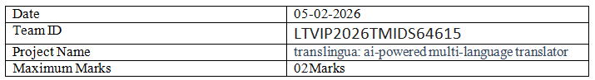

Technical Architecture:
The Resolve Now platform is designed with a scalable 3-tier architecture that includes the presentation layer (frontend), business logic (backend), and data storage layer. The solution ensures performance, security, and ease of integration with third-party APIs (e.g., Stripe for payments).

Table-1 : Components & Technologies:
S.No | Component | Description | Technology
 | User Interface | Web-based interface for clients and freelancers | HTML, CSS, JavaScript / React Js etc.
 | Application Logic-1 | Complaints posting | Node.js, Express.js
 | Application Logic-2 |  | React js, Node js
  Admin panel
 | Database | Stores user data, jobs, applications, messages | MongoDB

Table-2: Application Characteristics:
S.No | Characteristics | Description | Technology
 | Open-Source Frameworks | Frontend frameworks | React.js, Node.js, BootStrap, Tailwind CSS
 | Scalable Architecture | 3-tier architecture with RESTful APIs | Microservices

